



**Master Thesis**

**Estimating the Duration of Screen Time from Screenplays**

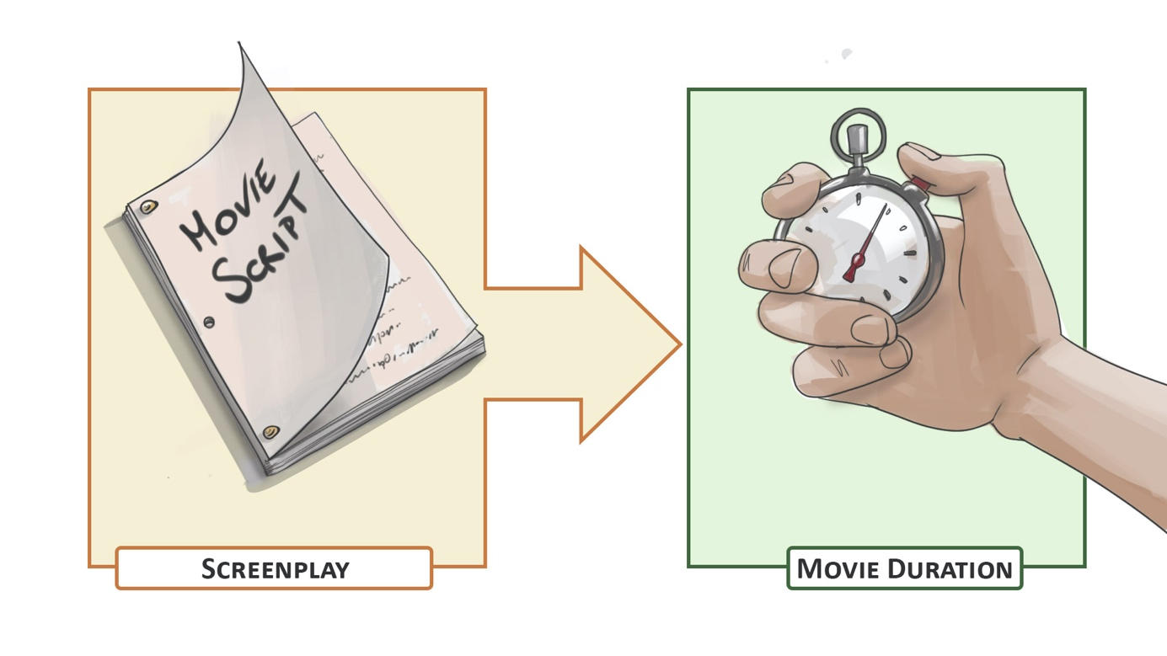

# Project Description

Screenplays are specifically formatted documents that describe how a story should be filmed. The format is structured such that one page of a screenplay is intended to take one minute of screen time. While this has become a well-known rule-of-thumb, it is not clear how well it corresponds to reality. At Disney Research | Studios, we aim to investigate the relationship between screenplay and the duration of the produced video content. The focus of this project will be to develop and assess more sophisticated techniques (e.g. rule-based, NLP or ML models) to predict screen time from screenplays, across different media (e.g. film and television) and different genres.

# Skills

* Proficiency in Python
* Experience in Natural Language Processing and Machine Learning
* Experience in data collection

# Remarks

A written report and an oral presentation conclude the thesis. The thesis will be overseen by Prof. Robert W. Sumner or Prof. Markus Gross, Steven Poulakos (DRS) and Eleftheria Tsipidi (ETH). Please contact Steven Poulakos ([steven.poulakos@disneyresearch.com](mailto:steven.poulakos@disneyresearch.com)) for more information.